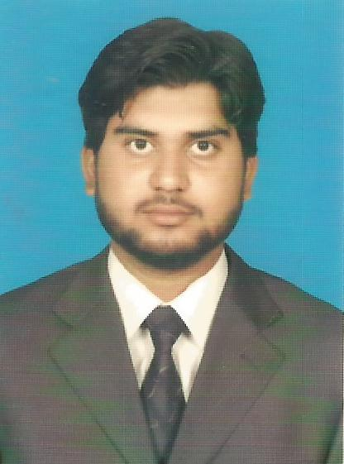
Curriculum Vitae:
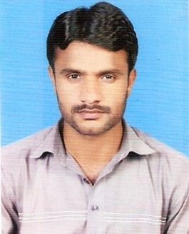

- Muhammad Tahir Taswar S/O Taswar Hussain
- Cell# Contact only Whats app +92302-7380135- 0306-7316931
- Iraq(baghdaad) +9647725497454
- House#77 E Block Shah Rukn e Alam Colony Multan.Pakistan.

E-Mail : raotahirtn@gmail.com

Nationality : Pakistani
Date of Birth : 07-08-1998
Marital Status : Single
N.I.C Number : 36303-9439793-7
Domicile : Multan (Punjab)
Country. : Pakistan
Religion : Islam

Muhammad Tahir Taswar

OBJECTIVE

Seeking opportunities to work in highly professional organization where I can participate to enhance business of the company by using my proven abilities.

QUALIFIFICATION

SR. NO. | DEGREE | INSTITUTE / BOARD | MARKS / % AGE | YEAR OF PASSING
 | DAE Mechanical  (Engineering) | PBTE Lahore | 76% | 2015
 | Matriculation | BISE Multan | 65% | 2012

Extra Qualification & Experience

Fatima Fertilizer Company(FFC) & Foji Fertilizer Bin Qasim Limited (FFBL)

I have Work in Fatima Fertilizer Sadiqabaad and Fauji Fertilizer Mirpur Mathelo as Lift Elevator 'Mantinance Technician' Through a Private Contractor(03Month). Krachi(Pakistan)

Krones Contiroll Labller (K745T56) & (K745T60)& SoloModul K-406-288

= 2 Year Experience in Gourmet Cola Beverage and Food (FMCG) Industry as A Labller Countiroll 'Machine Supervisor' at Krones Pet Line(24000 Bottal per Hour). Multan(pakistan).

= 1 Experience in Gourmet Cola Beverage and Food(FMCG) Industry As A Labller Machine Operator at "SoloModul K-406-288 Ergo Block Pet Line(40000 Bottal per Hour).Multan(Pakistan).

= I have Experiance of Labller countiroll Machine as 'Mantinance Technician' in Gourmet Cola Beverage and Food(FMGC) in Multan.(Pakistan)

Preventive maintenance, OpportunityMaintenance, shut down jobs and Minor jobs

Operation Erection & commissing on Krones Maintenance, packing conveyor, Robobox, palatizor & pallet conveyor
I am worked with krones engineers like Mr.Khurram & Mr.Mirza Sajjad Baig
Took part in Erection and Commissioning of ERGO BLOC with KRONES Team.

Gourmet ANC Food Multan.(Pakistan)
Labller Countiroll 'Machine Supervisor Krones Countiroll Pet line ”.
Responsibilities & duties
- Trouble shootings
- Reporting to Shift Incharge
- Implementation of standard operating
- Responsible of daily recording of Reports
- Reduction of break downs of machine
- Operational performance of all molds
- To ensure personal safety
- To reduce wastages of product and packing materials
TECH-LONG热熔贴标加油周期明细和保养事
Also working as Technician and operating experience of TECH-LONG Hot -Melt Glue Lablling Machine "SERIAL No-K107101(From 16May to Till Now. Country-Iraq(Baghdad)

I have experience in Alkhalj Alarbi Minral water 313 plant at Hot-Melt Glue Lablling Machine(25000 Bottal per Hour) As A "SENIOUR MACHINE TECHNiCIAN & OPERATOR".

I have Experience of Erection, Pre Commissioning, Commissioning, Installation, of Labller Machine , Conveyer Belts, Packing Conveyer Belts, Robobox Belt Conveyer, Palatiozer & Pellet Conveyer.
Preventive maintenance, Opportunity Maintenance, shut down jobs and Minor jobs.
Recovery of Operational breakdowns.
Responsibility & Duties
Maintenance Work.
Machine Operations.
Machine Maintenance.
Preventive Maintenance.
Perform the smooth and efficient operation at rated speed and follow Quality standards.
Maintain Daily checklist, on-line inspection and log book related to LABELER Machine.
Timely response/handling in case of any abnormality.
Perform and follow Preventive/Breakdown maintenance procedures regarding LABELER machine.
Ensure proper handling and record of Raw material.
Ensure minimum wastage of Raw material.
Perform quick changeovers(flavor/package) on machine as per requirement.
Machine cleaning/Lubrication and maintenance to keep machine in good working condition.
Give timely information about spare parts requirement.
Implementation of Quality, Food Safety and HSE management system. whatsoever

SKILL PROFILE

- Have an analytical approach.
- Good communication skill.
- Have a good command on English.
- Ability to work as a team member.
- High level of initiative & hard working.

Computer SKILLs

- Microsoft Office Word
- Microsoft Office Excel
- Microsoft Office PowerPoint

Languages

Proficiency | Read | Write | Speak
Urdu | Excellent | Excellent | Excellent
English | Excellent | Excellent | Good
Arabic | Normal | Excellent | Normal

Hobbies

- Reading
- Web surfing
- Playing cricket
REFRENCE

- Reference will be furnished on your demand.

